Computer Vision HW#8

B01902040 資訊四 鍾毓安

**Task Description**

1. Generate additive white Gaussian noise -- 2 photos
2. Generate salt-and-pepper noise -- 2 photos
3. Run box filter (3x3, 5x5) on all noisy images -- 8 photos
4. Run median filter (3x3, 5x5) on all noisy images -- 8 photos
5. Run opening followed by closing and closing followed by opening (grayscale, value = 0, octagon) -- 8photos

**Language & Tool**

1. Python + Numpy
2. OpenCV (for reading image only)

**Work Flow & Results**

Four functions were implemented:

1. generate_Gaussian_noise(img, mu, sigma, amplitude): the function generates Gaussian noise with the specified $μ$, $σ$, and amplitude on the given image.
2. generate_salt_and_pepper_noise(img, low, high, threshold): the function generates salt-and-pepper noise with the specified range for uniform sampling and threshold on the given image.
3. box_filter(img, filter_size): the function runs box filter with the specified filter_size on the given image.
4. median_filter(img, filter_size): the function median filter with the specified filter_size on the given image.

Once these four functions were implemented, the leading four tasks can be easily done by calling the functions with assigned parameters. The fifth task needs the API from hw5, so I copy the source code from hw5 and rename it to utils.py. Please check main.py for more details, my work flow is clearly commented.

The 28 resulting images are displayed in the next few pages.

**Generated Figures**

Task 1

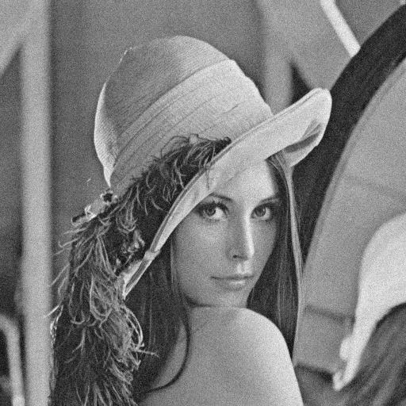 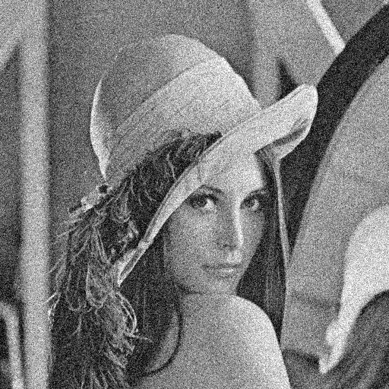

Task 2

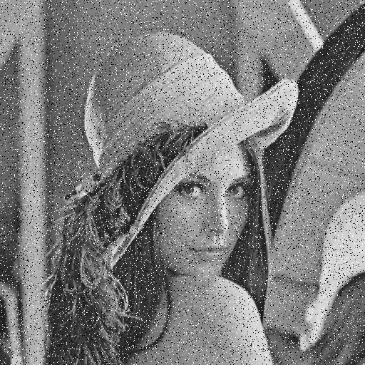 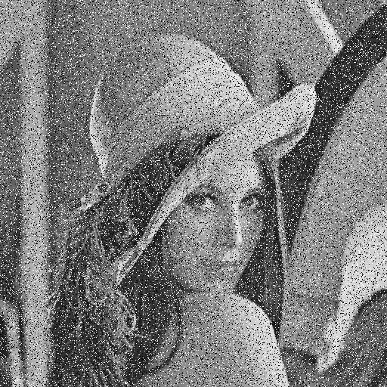

Task 3

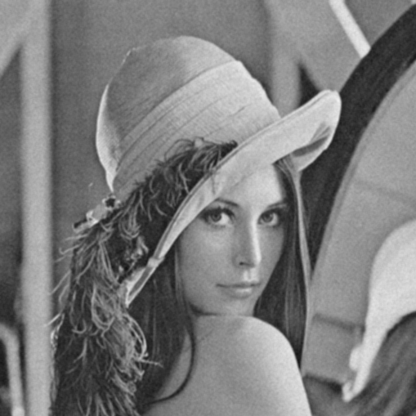 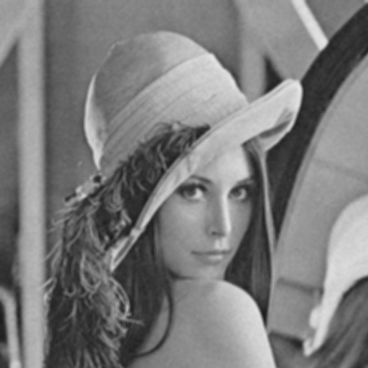

Gaussian-10-box-3x3 Gaussian-10-box-5x5

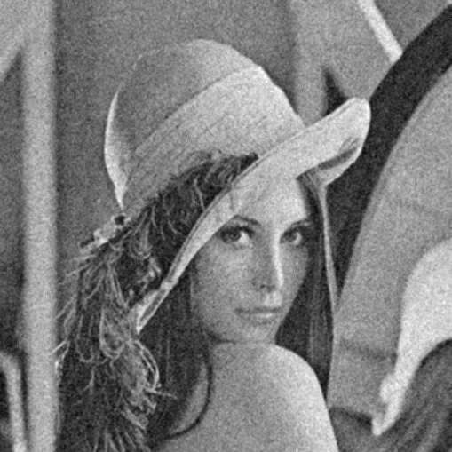 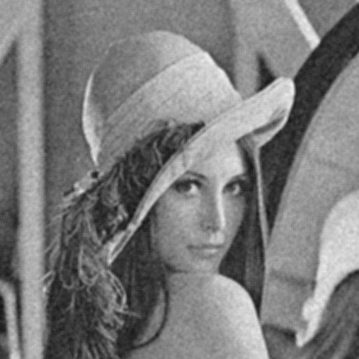

Gaussian-30-box-3x3 Gaussian-30-box-5x5

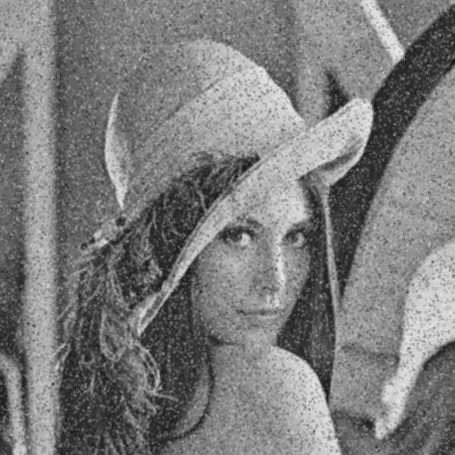 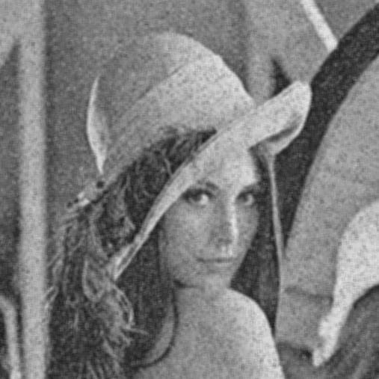

salt-and-pepper-0.05-box-3x3 salt-and-pepper-0.05-box-5x5

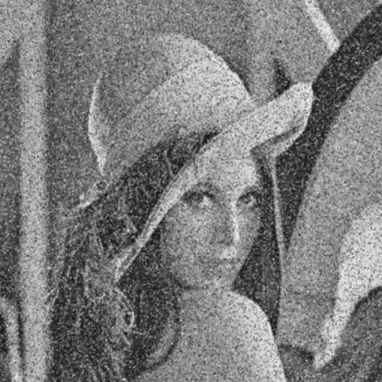 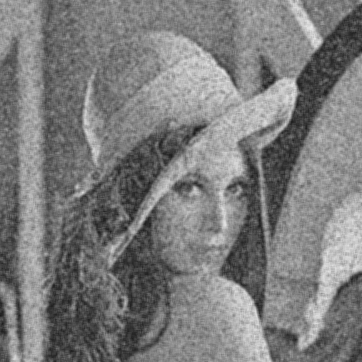

salt-and-pepper-0.1-box-3x3 salt-and-pepper-0.1-box-5x5

Task 4

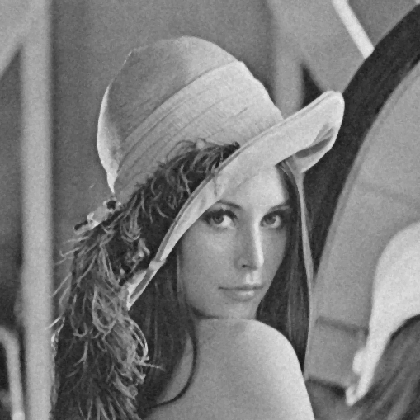 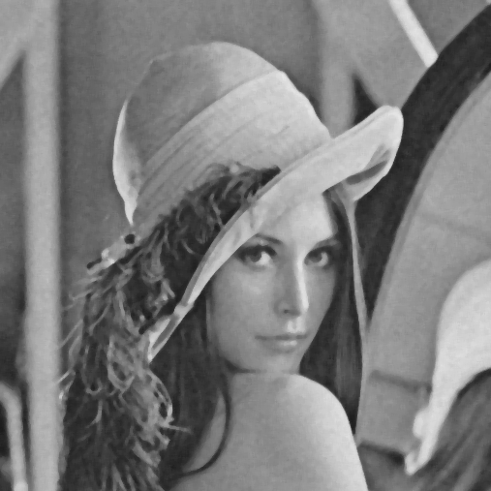

Gaussian-10-median-3x3 Gaussian-10-median-5x5

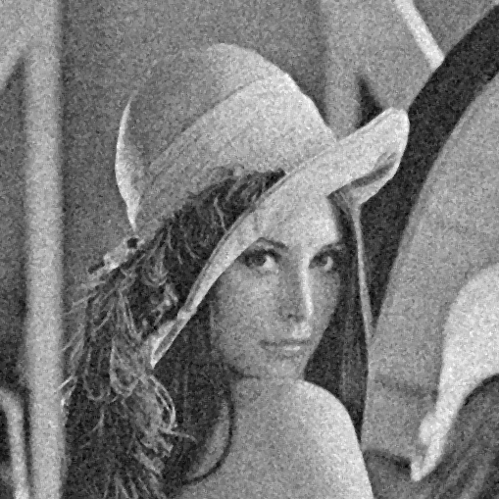 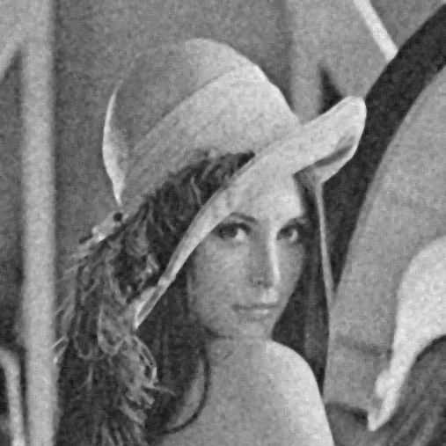

Gaussian-30-median-3x3 Gaussian-30-median-5x5

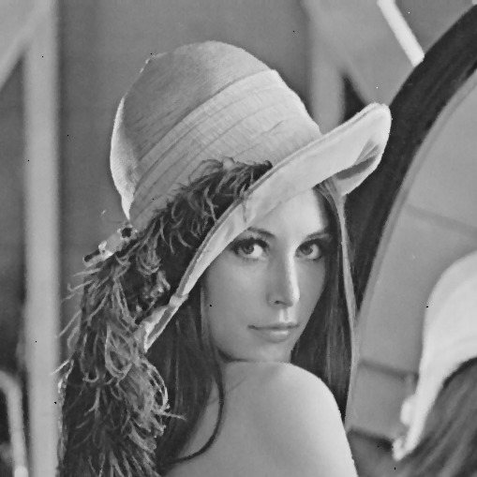 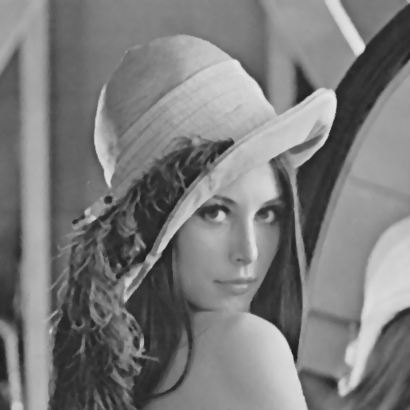

salt-and-pepper-0.05-median-3x3 salt-and-pepper-0.05-median-5x5

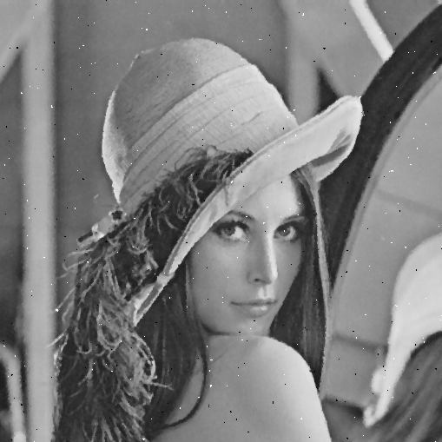 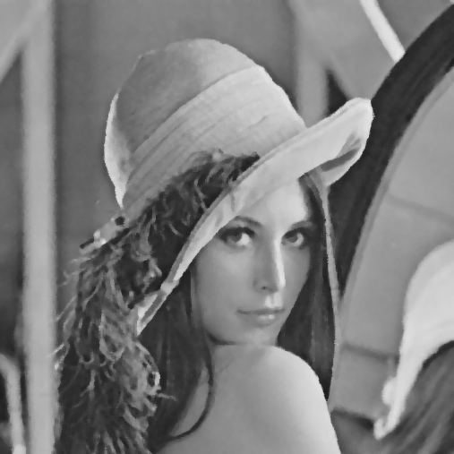

salt-and-pepper-0.1-median-3x3 salt-and-pepper-0.1-median-5x5

Task 5

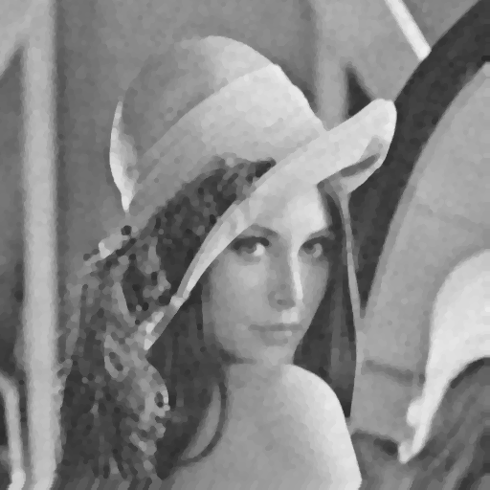 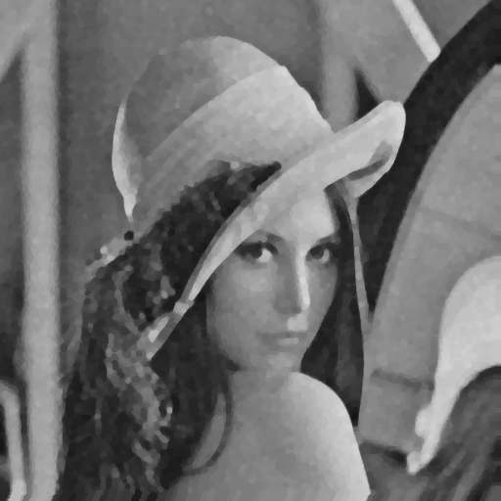

Gaussian-10-close-open Gaussian-10-open-close

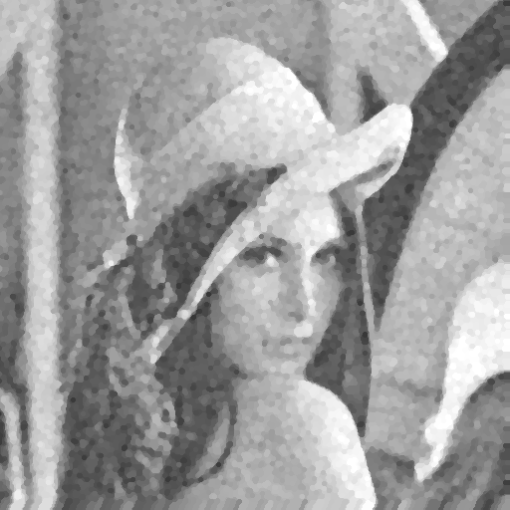 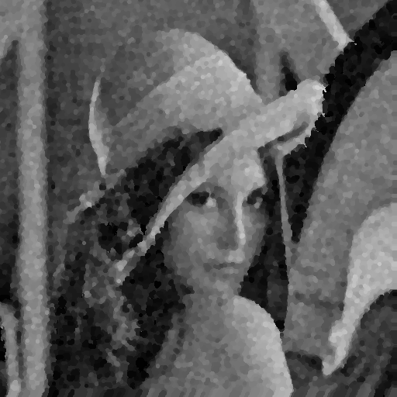

Gaussian-30-close-open Gaussian-30-open-close

 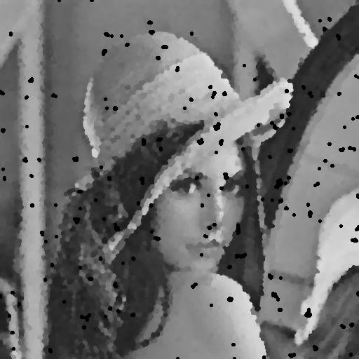

salt-and-pepper-0.05-close-open salt-and-pepper-0.05-open-close

 

salt-and-pepper-0.1-close-open salt-and-pepper-0.1-open-close

**Reproduction**

To reproduce the result (all five tasks would be finished all at once), execute the following command:

>> python ./main.py